NAME : Pushti Shah SAP ID: 60019210097
ROLL NO: B074 SUB: Network Security
EXP 5

Implementation of Firewall using Iptables (with Vagrant)

Field | Details
Experiment No. | 5
Subject | Network Security Lab (NSL)
Topic | Firewall Implementation using Iptables
Tools Required | Vagrant, VirtualBox, Ubuntu 22.04 (Jammy)
Difficulty Level | Intermediate

1. Aim
To configure and test a network firewall using iptables on a Linux virtual machine, demonstrating the blocking and allowing of traffic based on IP addresses, protocols, and port numbers.

2. Objectives
- Set up a virtualized network environment using Vagrant with two VMs (server and client).
- Understand and apply iptables firewall rules on a Linux server.
- Test the effect of firewall rules on network connectivity.
- Block and allow specific traffic based on IP address, protocol (ICMP, TCP), and port.
- Persist firewall rules so they survive system reboots.

3. Theory

3.1 What is a Firewall?
A firewall is a network security system that monitors and controls incoming and outgoing network traffic based on predetermined security rules. It acts as a barrier between a trusted internal network and untrusted external networks. Firewalls can be hardware-based, software-based, or a combination of both.

3.2 What is Iptables?
iptables is a user-space utility program that allows system administrators to configure the IP packet filter rules of the Linux kernel firewall, implemented through the Netfilter framework. The filters are organized into three types of structures: tables, chains, and rules.

3.3 Iptables Architecture

Tables

Table | Purpose
filter | Default table; used for packet filtering (INPUT, OUTPUT, FORWARD)
nat | Network Address Translation
mangle | Specialized packet alteration
raw | Exemptions from connection tracking

Chains
Each table contains chains — ordered sequences of rules applied to packets:

- INPUT — Rules for packets destined for the local system.
- OUTPUT — Rules for packets generated by the local system.
- FORWARD — Rules for packets being routed through the system.

Rule Processing
Packets traverse chain rules sequentially. When a rule matches, the defined target (ACCEPT, DROP, REJECT, LOG) is applied and processing stops. If no rule matches, the default policy is applied.

3.4 Default Policies

Policy | Behavior
ACCEPT | Allow the packet (permissive default)
DROP | Silently discard the packet (recommended for INPUT)
REJECT | Discard and send an ICMP error back to sender

3.5 Vagrant Overview
Vagrant is an open-source tool for building and managing virtualized development environments using Vagrantfiles. For this experiment, Vagrant creates an isolated private network between two VMs, simulating a real-world client-server scenario without modifying the host machine.

4. Requirements

4.1 Software Requirements

Software | Version / Notes | Purpose
Vagrant | 2.x or higher | VM provisioning
VirtualBox | 6.x or higher | Hypervisor
Ubuntu 22.04 (Jammy) | ubuntu/jammy64 box | Guest OS
iptables | Pre-installed on Ubuntu | Firewall configuration
iptables-persistent | Installed during experiment | Persist rules across reboots
Apache2 | Installed during experiment | HTTP server for port 80 testing

4.2 Hardware Requirements
- Minimum 4 GB RAM (8 GB recommended for running 2 VMs simultaneously)
- At least 10 GB free disk space
- 64-bit processor with virtualization support (Intel VT-x / AMD-V enabled in BIOS)

5. Procedure

Step 1: Create Virtual Machines using Vagrant

1.1 Create Terminals
- Create two VsCode Terminals
- Name them as client and server

1.1 Configure the Vagrantfile
Open the Vagrantfile and replace all content with:

Vagrant.configure("2") do |config|
config.vm.define "server" do |server|
server.vm.box = "ubuntu/focal64"
server.vm.hostname = "server"
server.vm.network "private_network", ip: "192.168.56.10"
end
config.vm.define "client" do |client|
client.vm.box = "ubuntu/focal64"
client.vm.hostname = "client"
client.vm.network "private_network", ip: "192.168.56.11"
end
end

1.4 Start Both VMs (Server Terminal)
vagrant up

Verify both machines are running:

vagrant status

**Expected output:** Both `server` and `client` listed as `running`.

Step 2: Install and Verify Iptables on Server

2.1 SSH into the Server VM (Server Terminal)
vagrant ssh server

2.2 Update System and Install Packages Check Iptables**(Server Terminal)**
sudo apt update
sudo apt install iptables -y
sudo apt install apache2 -y

sudo iptables -L

Step 3: View Current Firewall Rules (Server Terminal)
sudo iptables -L -n -v

Output

Chain INPUT (policy ACCEPT 58 packets, 3328 bytes)
pkts bytes target prot opt in out source destination
Chain FORWARD (policy ACCEPT 0 packets, 0 bytes)
pkts bytes target prot opt in out source destination
Chain OUTPUT (policy ACCEPT 30 packets, 2360 bytes)
pkts bytes target prot opt in out source destination

✅ All incoming traffic is allowed

✅ All outgoing traffic is allowed

✅ No filtering is happening

By default on Ubuntu, all chains (INPUT, FORWARD, OUTPUT) have policy `ACCEPT` — all traffic is allowed.

Step 4: Apply Firewall Rules

4.1 Block All Incoming Traffic
**⚠️ Caution:** If we set the default policy to DROP while connected over SSH, your session will be terminated and we may lose access to the VM. To avoid this, add a rule to allow SSH before changing the policy.

Before changing the policy, add a rule to permit SSH so the remote session remains active (Server Terminal):

sudo iptables -A INPUT -p tcp --dport 22 -j ACCEPT

Now set the default INPUT policy to DROP (Server Terminal):

sudo iptables -P INPUT DROP

From a new terminal, SSH into the client and test (Client Terminal):

vagrant ssh client
ping 192.168.56.10

**Expected:** Ping fails — no response from server.

vagrant@client:~$ ping 192.168.56.10
PING 192.168.56.10 (192.168.56.10) 56(84) bytes of data.
^C
--- 192.168.56.10 ping statistics ---
38 packets transmitted, 0 received, 100% packet loss, time 37981ms

4.2 Allow ICMP (Ping)
On the server, allow ICMP (Server Terminal):

sudo iptables -A INPUT -p icmp -j ACCEPT

Test again from the client (Client Terminal):

ping 192.168.56.10

**Expected:** Ping succeeds.

vagrant@client:~$ ping 192.168.56.10
PING 192.168.56.10 (192.168.56.10) 56(84) bytes of data.
64 bytes from 192.168.56.10: icmp_seq=1 ttl=64 time=0.429 ms
64 bytes from 192.168.56.10: icmp_seq=2 ttl=64 time=0.441 ms
64 bytes from 192.168.56.10: icmp_seq=3 ttl=64 time=0.518 ms
64 bytes from 192.168.56.10: icmp_seq=4 ttl=64 time=0.594 ms
^C
--- 192.168.56.10 ping statistics ---
4 packets transmitted, 4 received, 0% packet loss, time 3038ms
rtt min/avg/max/mdev = 0.429/0.495/0.594/0.066 ms

4.3 Allow HTTP Traffic (Port 80)
Allow HTTP through the firewall (Server Terminal):

sudo iptables -A INPUT -p tcp --dport 80 -j ACCEPT

Test from the (Client Terminal):

curl 192.168.56.10

**Expected:** Apache default page HTML content is displayed.

Step 5: Block a Specific IP Address
Block the client machine entirely (Server Terminal):

Note on Rule Order: iptables evaluates rules from top to bottom. Because we added broad ACCEPT rules in Step 4, we must insert (-I) this DROP rule at the top of the list (Line 1). If we appended it (-A), the firewall would accept the traffic before ever reading the drop rule!

sudo iptables -I INPUT 1 -s 192.168.56.11 -j DROP

**Expected:** Ping and curl from the client both fail.

Ping from (Client Terminal)

ping 192.168.56.10

Curl from (Client Terminal)

curl 192.168.56.10

Step 6: Delete a Firewall Rule (Server Terminal)
List rules with line numbers:

sudo iptables -L --line-numbers

Delete a specific rule by its number (e.g., rule 3):

sudo iptables -D INPUT 3

6. Observations and Results
Test | Rule Applied | Expected Result | Actual Result
Ping before any rules | None (Default ACCEPT) | Success | Success
Ping after INPUT DROP policy | iptables -P INPUT DROP | Fail | Fail
Ping after allowing ICMP | iptables -A INPUT -p icmp -j ACCEPT | Success | Success
SSH access from client | iptables -A INPUT -p tcp --dport 22 -j ACCEPT | Success | Success
HTTP before allowing port 80 | No HTTP rule | Fail | Fail
HTTP after allowing port 80 | iptables -A INPUT -p tcp --dport 80 -j ACCEPT | Success | Success
All access after blocking client IP | iptables -A INPUT -s 192.168.56.11 -j DROP | Fail | Fail
After deleting block rule | iptables -D INPUT <n> | Restored | Restored
After reboot (persistent rules) | netfilter-persistent save | Rules Active | Rules Active

7. Screenshots
Attach screenshots for each of the following:
- vagrant up output showing both VMs running

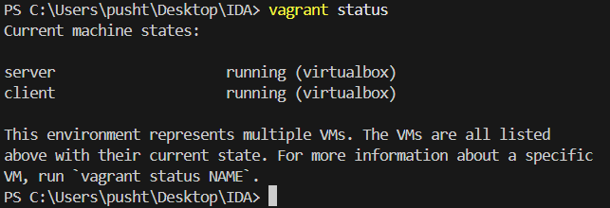

- sudo iptables -L -n -v showing default rules
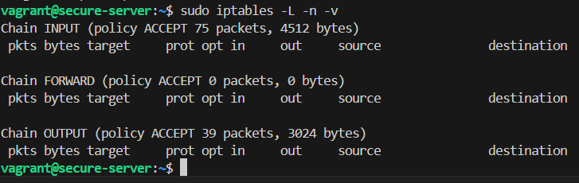

- Ping failure after setting INPUT DROP
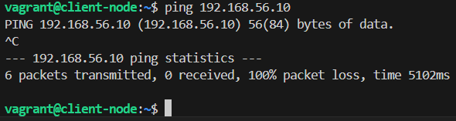

- Ping success after allowing ICMP

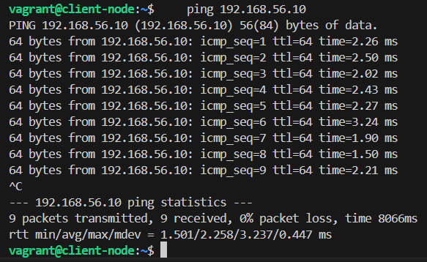
- curl output showing Apache default page
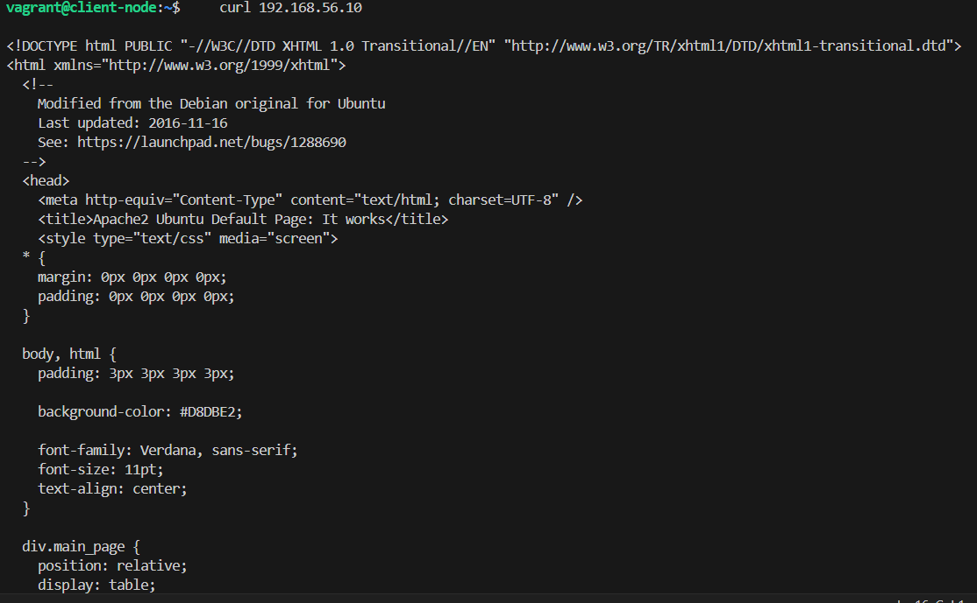
- Ping/curl failure after blocking client IP
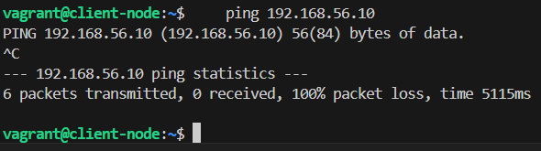
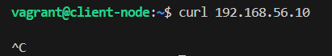
- iptables -L --line-numbers output
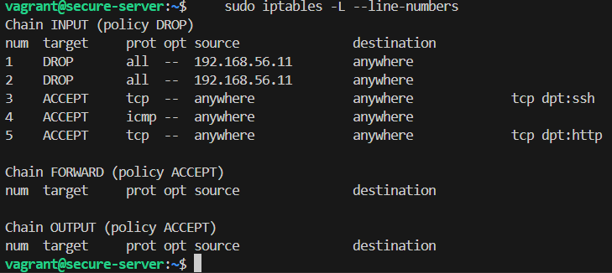

8. Iptables Command Reference
Command / Flag | Description | Example
iptables -L | List all rules in all chains | sudo iptables -L -n -v
iptables -P | Set default policy for a chain | sudo iptables -P INPUT DROP
-A (Append) | Add rule at end of chain | iptables -A INPUT -p icmp -j ACCEPT
-D (Delete) | Delete a rule by line number | iptables -D INPUT 3
-F (Flush) | Delete all rules in a chain | sudo iptables -F INPUT
-p | Match a protocol | -p tcp / -p udp / -p icmp
--dport | Match destination port | --dport 22, --dport 80
-s | Match source IP address | -s 192.168.56.11
-j | Action to take on match | -j ACCEPT / -j DROP / -j REJECT
--line-numbers | Show rule numbers when listing | iptables -L --line-numbers

10. Conclusion
In this experiment, we successfully:

- Created a virtualized client-server network environment using Vagrant and VirtualBox.
- Configured a Linux firewall using iptables on the server VM.
- Applied and tested rules to block all incoming traffic by default (default-deny).
- Selectively allowed ICMP (ping), SSH (port 22), and HTTP (port 80) traffic.
- Blocked a specific client IP address from all server access.
- Deleted individual rules without affecting others.
- Persisted firewall rules across reboots using iptables-persistent.

This experiment demonstrates the fundamental principles of firewall configuration rule-based packet filtering using a default-deny policy followed by explicit whitelisting of required services. These skills are foundational to network security administration.

